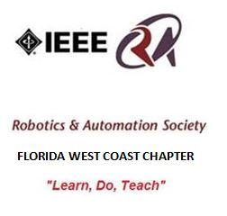

Minutes of the 07/15/2014 IEEE Tampa Bay RAS Meeting
(Prepared by Sean Denny, Chapter Chair)

Location: USF Tampa Campus,
4202 E Fowler Ave, Tampa, FL 33620
Room: ENB 110
Date: July 15, 2014
Time: 6:00pm to 6:55pm

The Tampa Bay Chapter of IEEE’s Robotics and Automation Society held the July meeting at University of South Florida in Tampa. The IEEE RAS Chapter plans to execute on the Vision of the Chapter’s Founder, George Schott to “Learn, Do, Teach”.

There were a total of 15 people made of 4 IEEE members, 10 IEEE Students, and 1 guest present.

OFFICER ROLL CALL:

o Chairman – Sean Denny
o Treasurer – Jim Cavanaugh

PRESENTATIONS:
- SPEAKER#1: TJ Ross, IEEE FWCS Student Chair talked about IEEE USF Robotics.
- Southeast Con Conference 2013 in Jacksonville, FL: Built robot to navigate a field.
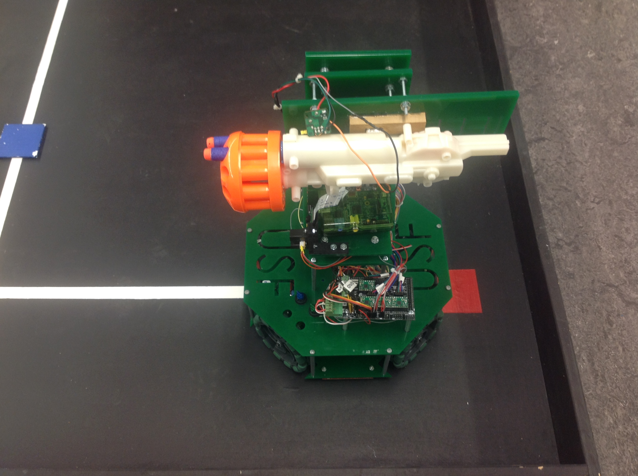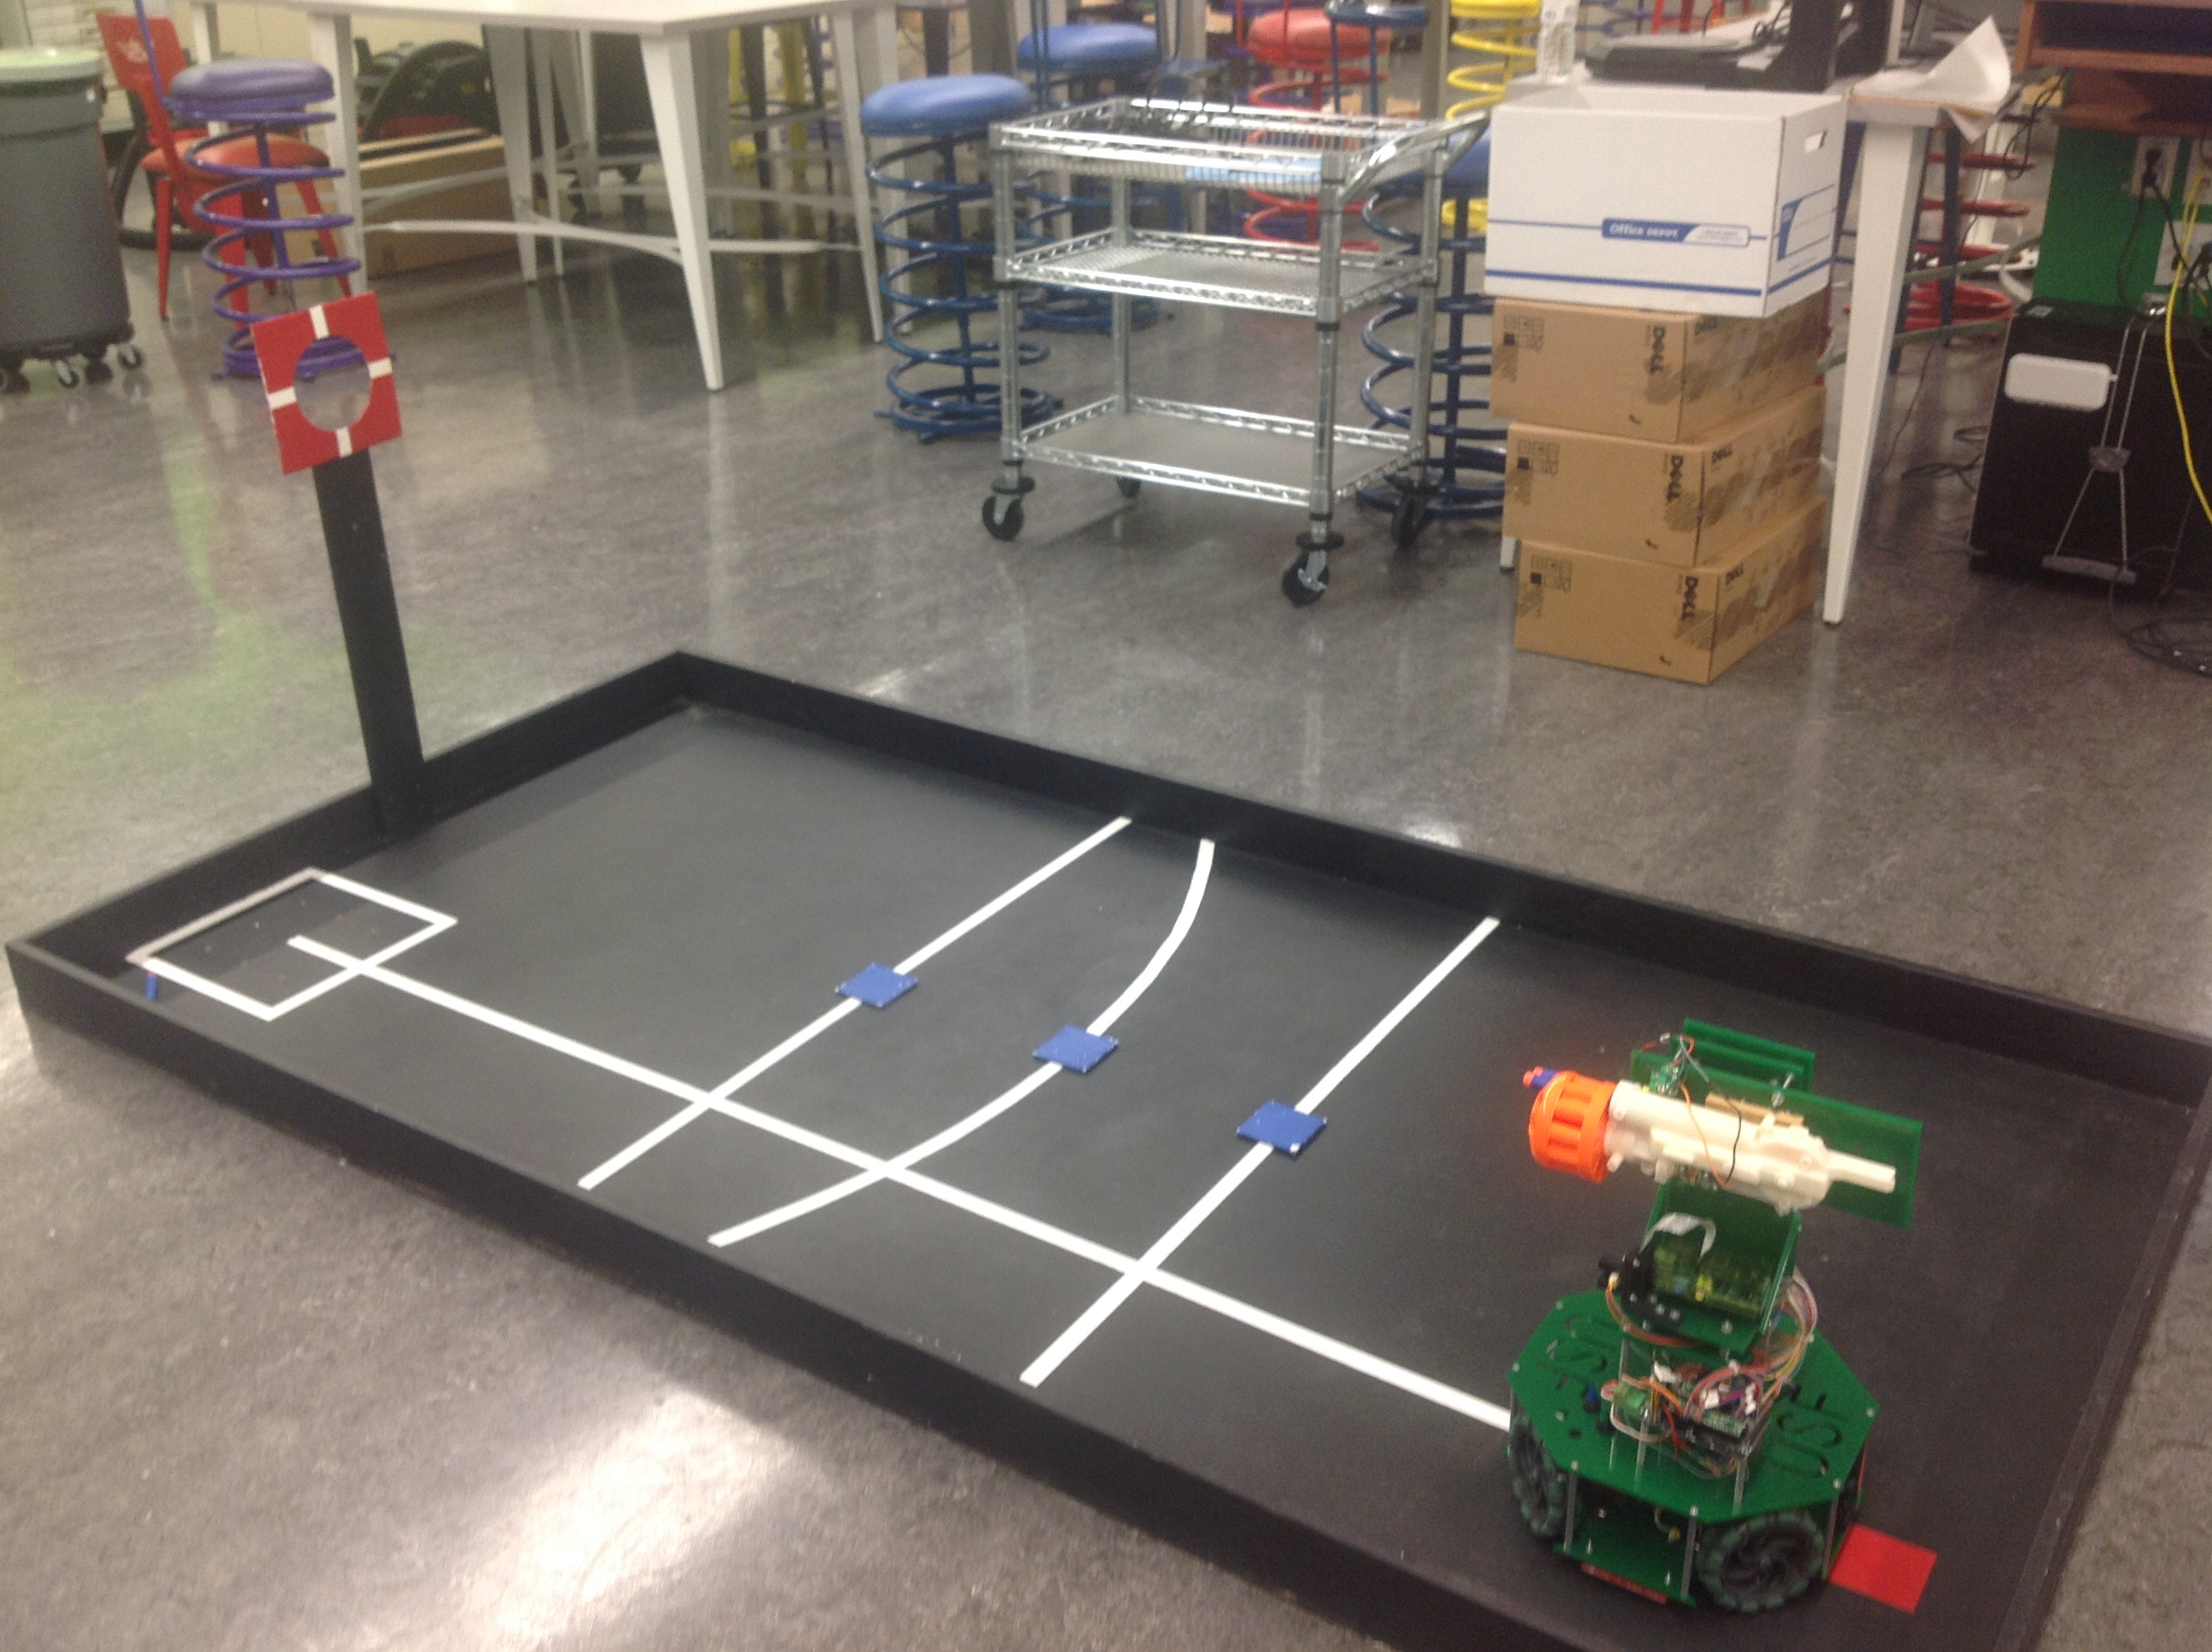
- Southeast Con Conference 2014 in Lexington, KY. The goal was to have a fully autonomous robot and finish the course in 2 minutes. The robot was made of Arduino Mega, Photodetectors, Omni-directional wheels, Servo Motors, IR Sensors, Raspberry PI, and onboard camera. They placed 18th out of 52 teams. They thank Dr. Sanjukta Bhanja for her help and support. The robot is unofficially named “Raging Bull.” TJ ran a demonstration of the robot which shot NERF Projectiles at three specific positions.
- Southeast Con 2015 Hardware Competition will be in Fort Lauderdale, FL. Preparations in progress.
- SPEAKER#2: Ken Fiallos gave an update for the FL Robotic Alliance Competition this fall.
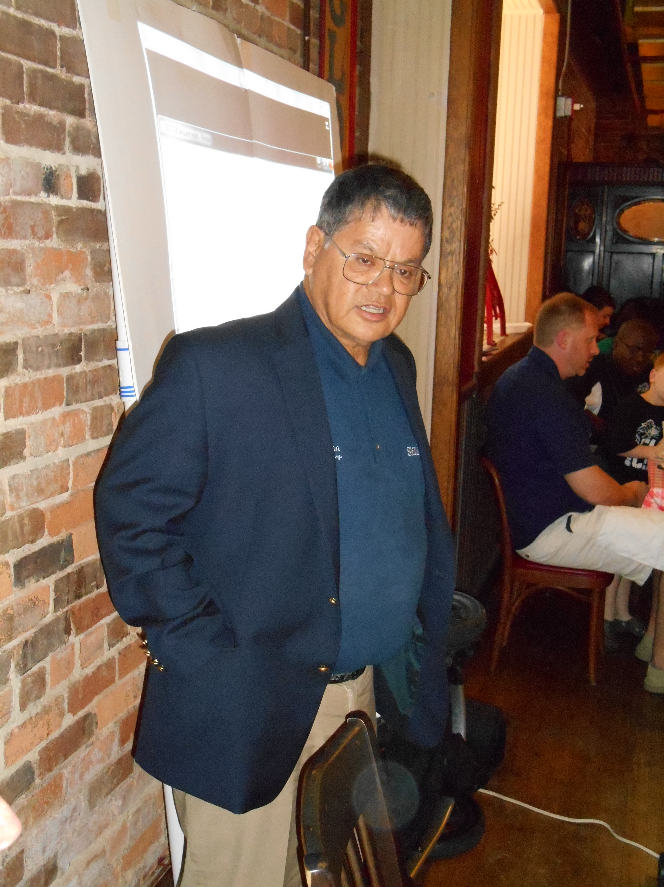
Ken said our IEEE RAS Chapter is a K-12 Resource. High School students are participating in Robotics Competitions. The current existing programs are expensive. The Local community helps increase the exposure for Robotics and Automation. Students must have business as well as Robotic technical skills.
BEST allows users to check out a returnable kit. We ran a BEST competition in Hillsborough County in 2013.
Hillsborough County Schools has decided to promote another competition under the FL Robotic Alliance. We are giving students a chance with the BIZBOTS competition this year. Ten week program with a business plan and will end with a competition in December. The competition “Main Street Yogurt Cooperative Inc” competition involves assembling the elements of yogurt in a factory setting in a fixed amount of time. They pick up the supplies, mix the ingredients, and deliver. We are looking for volunteer judges, referees, Robot C, Refurbish last year’s kits, check speed controllers, Word Press/Website, and Field Makers to help with the teamwork.
Key dates are:
9/27: Kick Off Day at Brandon HCC
11/15: Game Exhibition Practice at HCC Plant City
12/6: Competition Day at HCC Dale Mabry Campus or McClane Middle School
NEW BUSINESS:

- RAS CHAPTER CALENDAR
The Chapter Meeting dates for the remainder of 2014 are:

August 19: FRA Report by Ken Fiallos
September 16: FIRST Update by Terri Willingham
October 21: Tour of the Germany Library Downtown Tampa
Note: Announcements in the IEEE Signal Newsletter are due two months before the event.
OLD BUSINESS:
The Motion to approve the June Minutes as published was made by Ken Fiallos;
Seconded by Jim Cavanaugh. There was no discussion and the motion passed unanimously.

Treasurer Jim Cavanaugh reported we had a previous balance of $180.00. Tonight we collected $15 bringing the balance to $195.00.

Special thanks to Emma Alaba for taking the pictures.

Adjourned at 6:55pm by Emma Alaba; Seconded by Ken Fiallos.

Respectfully submitted by
Sean Denny,
Tampa Bay IEEE RAS Chapter Chair
venner20@ieee.org
727-678-0183

