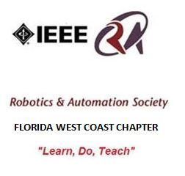

Minutes of the 9/16/2014 IEEE Tampa Bay RAS Meeting
(Prepared by Sean Denny, Chapter Chair and Recording Secretary)

Location: DeVry University at 5540 W. Executive Drive,
Tampa, FL, 33609
Room: 214
Date: September 16, 2014
Time: 6:30pm to 8:40pm

The Tampa Bay Chapter of IEEE’s Robotics and Automation Society held the September meeting at DeVry University in Tampa. The IEEE RAS Chapter plans to execute on the Vision of the Chapter’s Founder, George Schott to “Learn, Do, Teach”.

There were a total of 12 people made of 3 IEEE members, 5 Students, and 4 guests present.

OFFICER ROLL CALL:

o Chairman – Sean Denny
o Treasurer – Jim Cavanaugh

PRESENTATIONS:
- SPEAKER#1 FIRST ROBOTICS
Terri Willingham, Regional Director for FIRST in central FL, and a partner in the Eureka! Factory, an experiential learning and consultation company, provided an exciting discussion and demonstration on FIRST Robotics in the Tampa Bay Area.
For Inspiration and Recognition of Science and Technology (FIRST) was founded by Dean Kamen in 1989 to promote STEM education in schools through Project Based Learning. Their website is www.usfirst.org.
The Family of Programs include: Jr. FIRST Lego League (GRADE K-3), FIRST Lego League (GRADE 4-8), FIRST Robotics Competition (High School), and FIRST Tech Challenge (High School). The robot cannot be over 125 pounds. The business plan and Engineering Journal are necessary for the students to keep track of their competition.
There is a 12 week build period before the competition. The local competition is held in Orlando, FL. Super Regional is in San Antonio, Texas. World Competition is held in St. Louis.
We discussed the FIRST Outreach of the Tampa Bay Area. The VISTA program is trying to get FIRST into other schools. George Vera is trying to support STEM in Tampa for Boys & Girls Club Teams. They are asking Organizations like IEEE to support with Mentors.
Studies have shown FIRST alumni are more likely to attend college, more likely to major in engineering, pursue a career in Engineering, more likely to volunteer in the community, and more likely to major in engineering.
Teams are viewed as a corporate experience. For example, Spruce Creek High School has developed FIRST as a Curriculum Program. Currently it is considered an afternoon after-school program.
Team Duct Tape Alumni Joel Croteau talked about how FIRST helped him. He is the mentor for the Edgar Allen Ohms Team. They won an Inspire Award to help other teams at a recent competition. The Robots from Team Duct Tape and Edgar Allen Ohms were demonstrated.
We were invited to the Roboticon Festival on October 11 and 12 at the University of Tampa Bob Martinez Athletic Center. They asked if the IEEE Student Chapter could have a table.
The John F. Germany Library’s new Makerspace in Downtown Tampa called the Hive. IEEE RAS have been invited to have a RAS October Meeting at 6pm on October 21.
OLD BUSINESS:

The Motion to approve the August Minutes as published was made by Jim Cavanaugh; Seconded by Ken Fiallos. There was no discussion and the motion passed unanimously.

NEW BUSINESS:

- RAS CHAPTER CALENDAR
The Chapter Meeting dates for the remainder of 2014 are:

October 21: Tour of the John F. Germany Library at 6pm.

November 18: Laurie Newkirk, Withlacoochee Technical Institute Instructor, Automation & Production Technology from Citrus County, will present her program at Westshore DeVry University at 6:30pm.

December 16: Officer Election and 2015 Planning

January 20: Tour of East Lake Public Library 6pm.

Note: Announcements in the IEEE Signal Newsletter are due two months before the event.

Meeting adjourned at 8:40pm.

Respectfully submitted by
Sean Denny,
Tampa Bay IEEE RAS Chapter Chair
venner20@ieee.org
727-678-0183
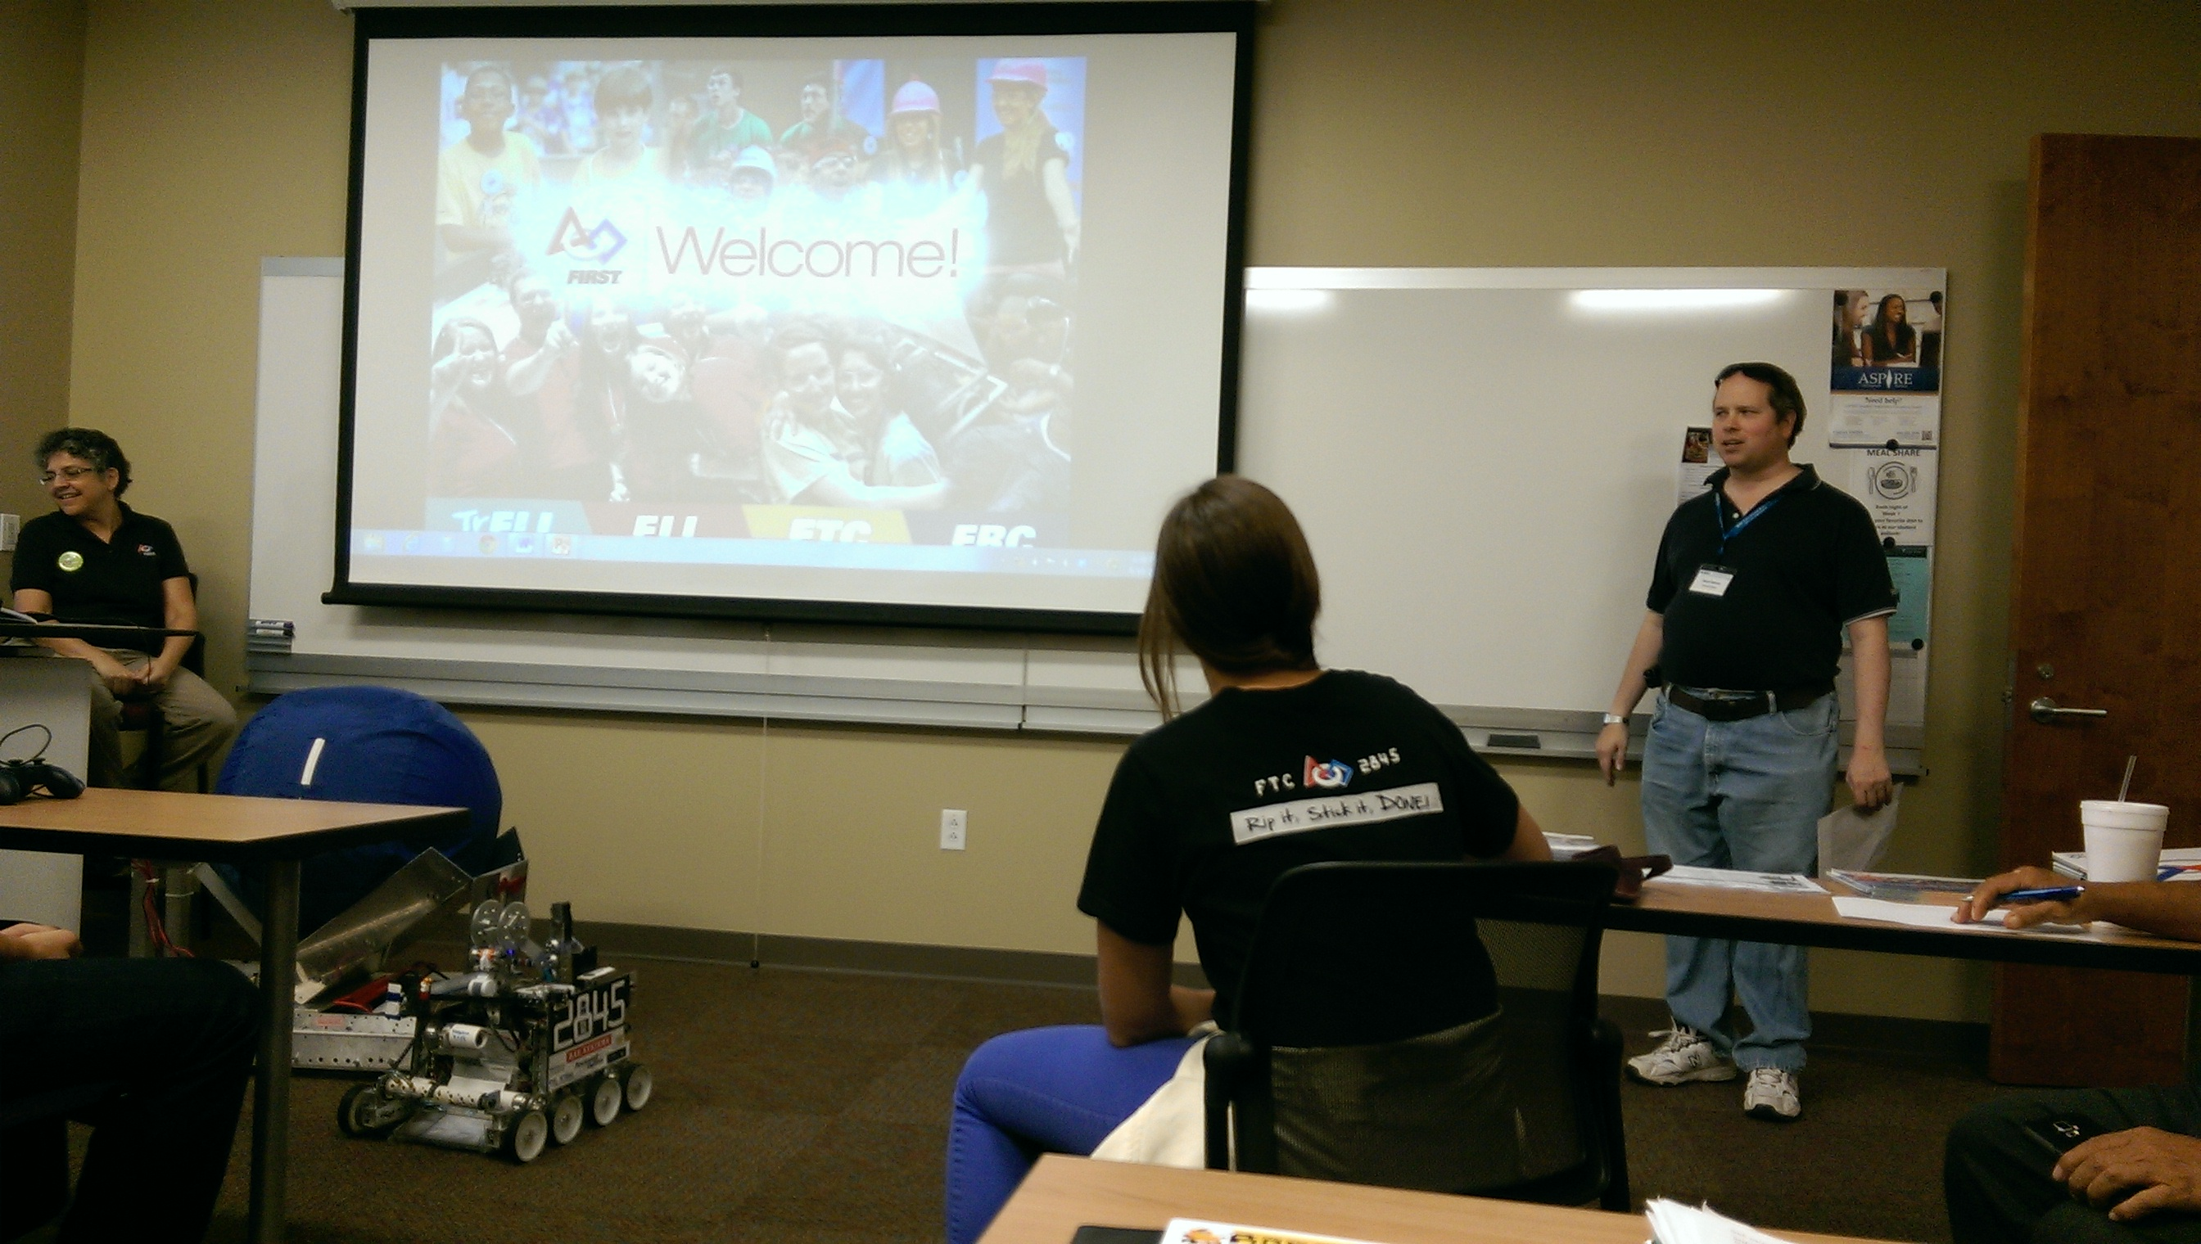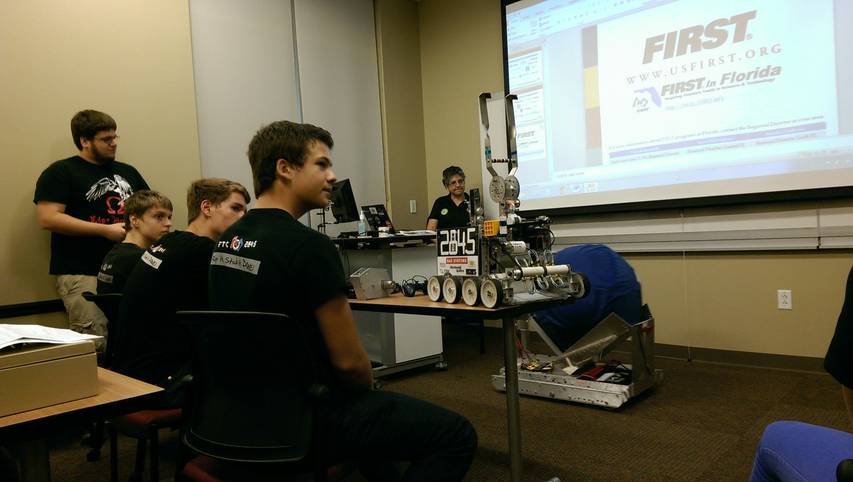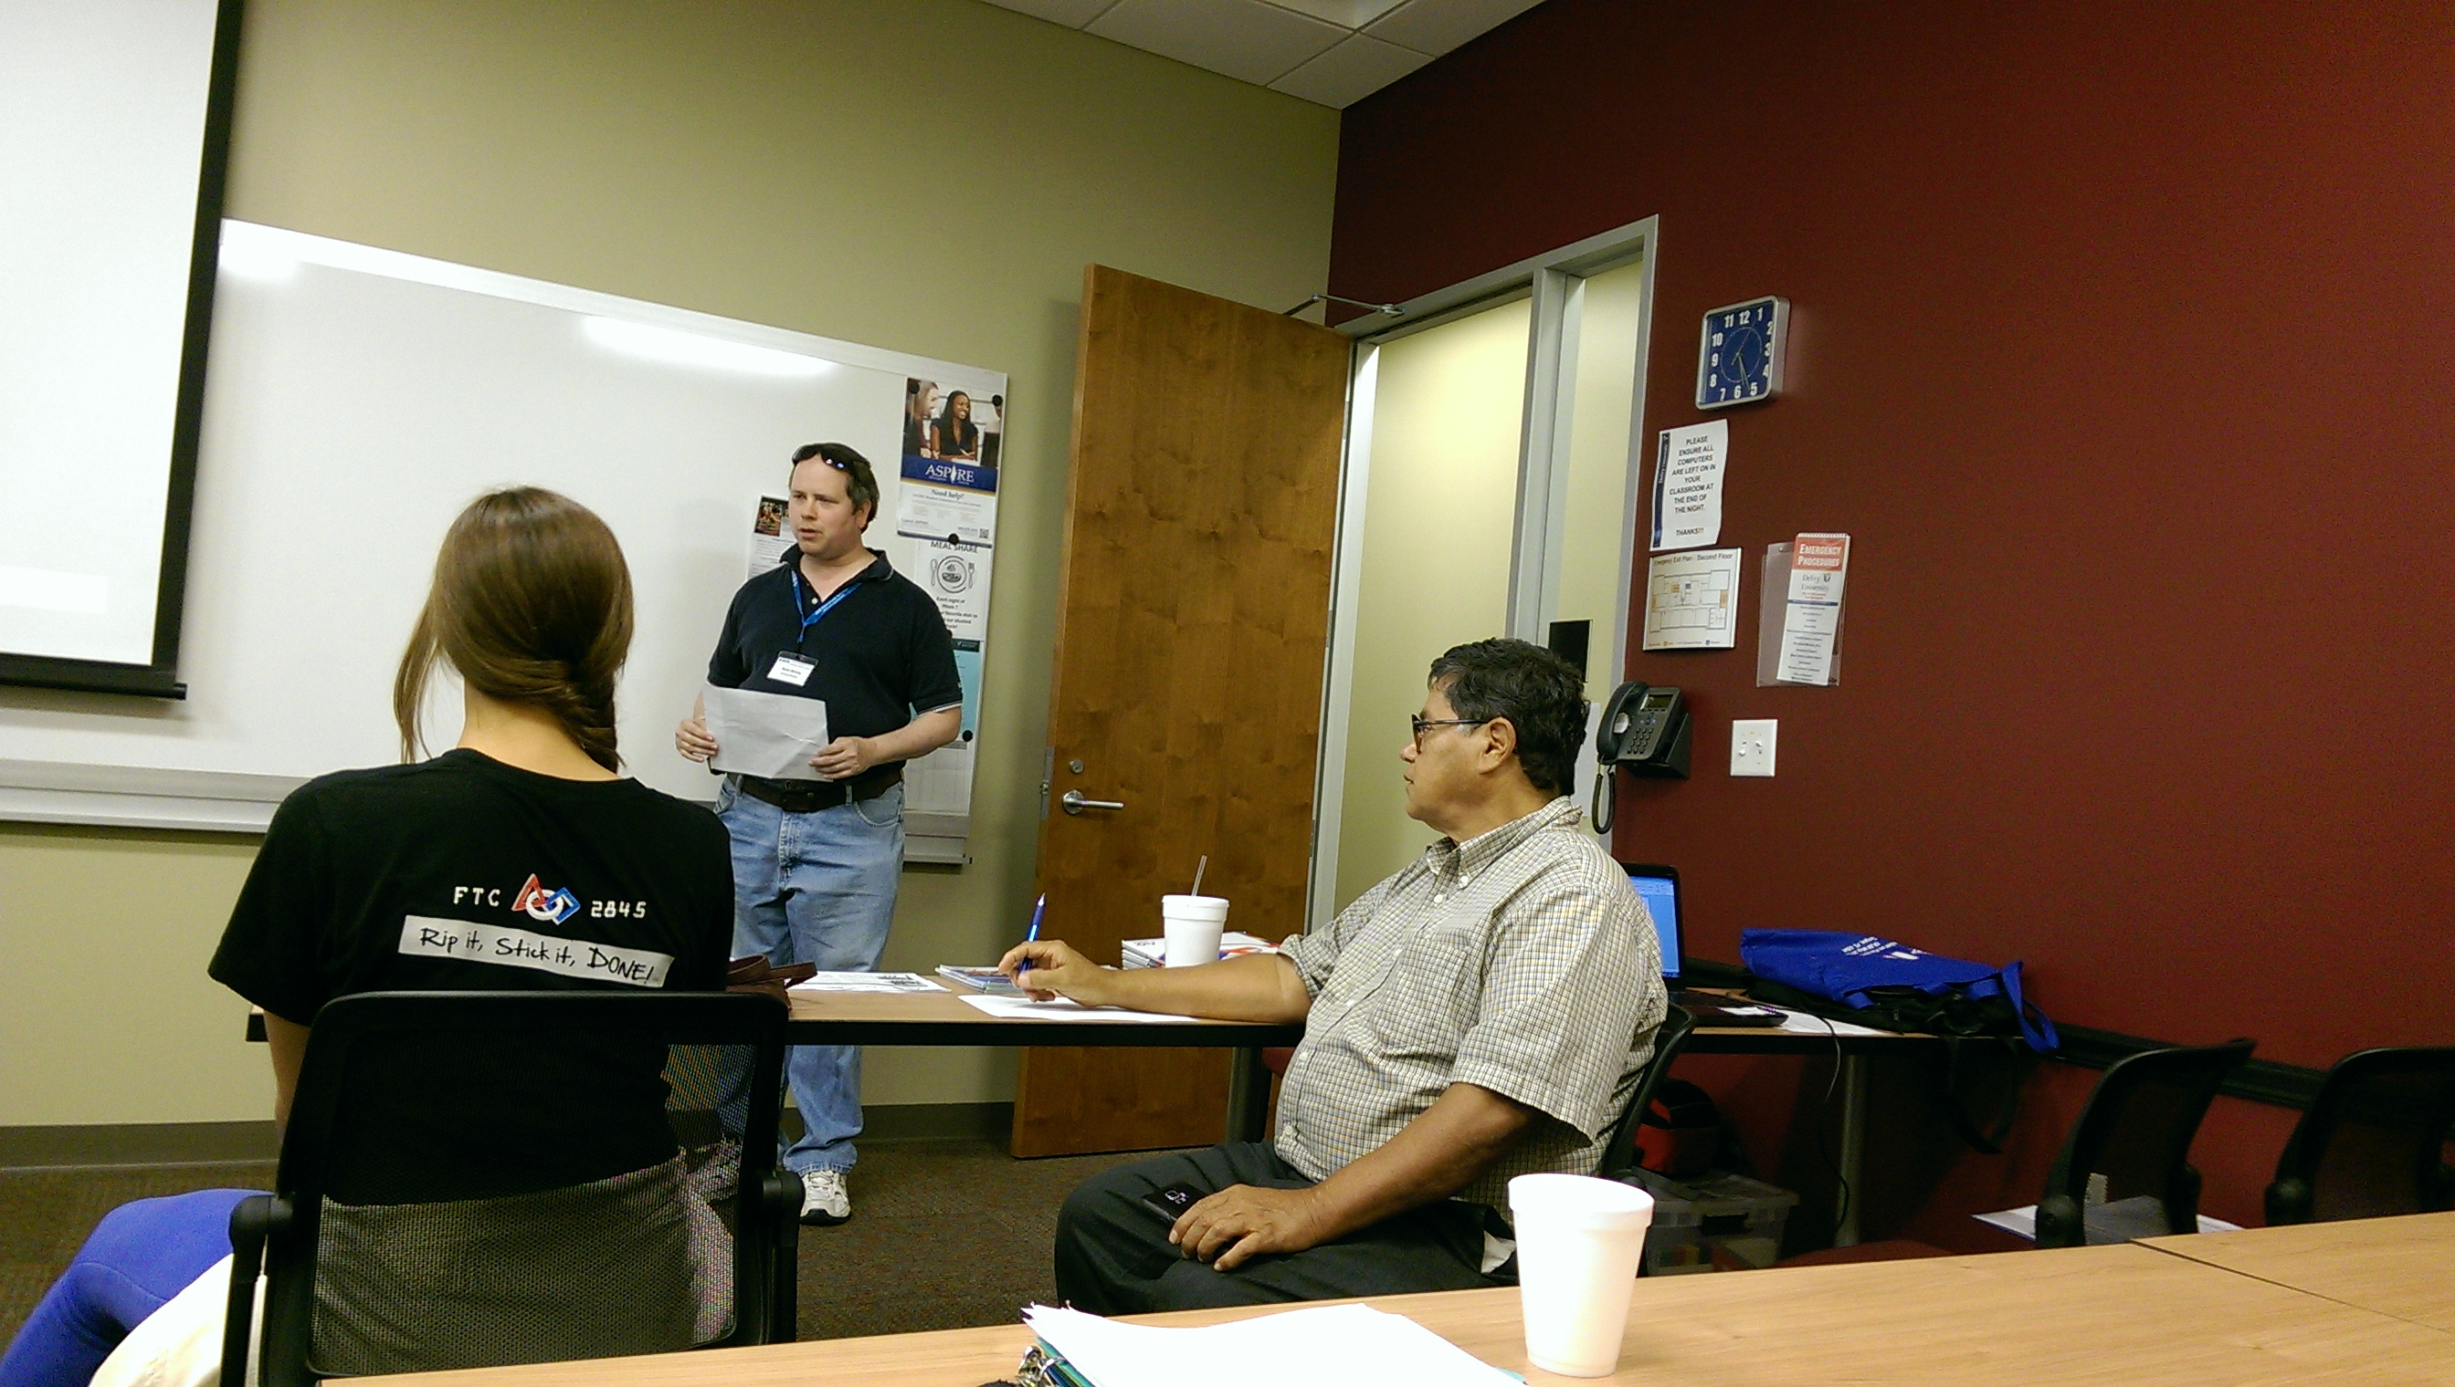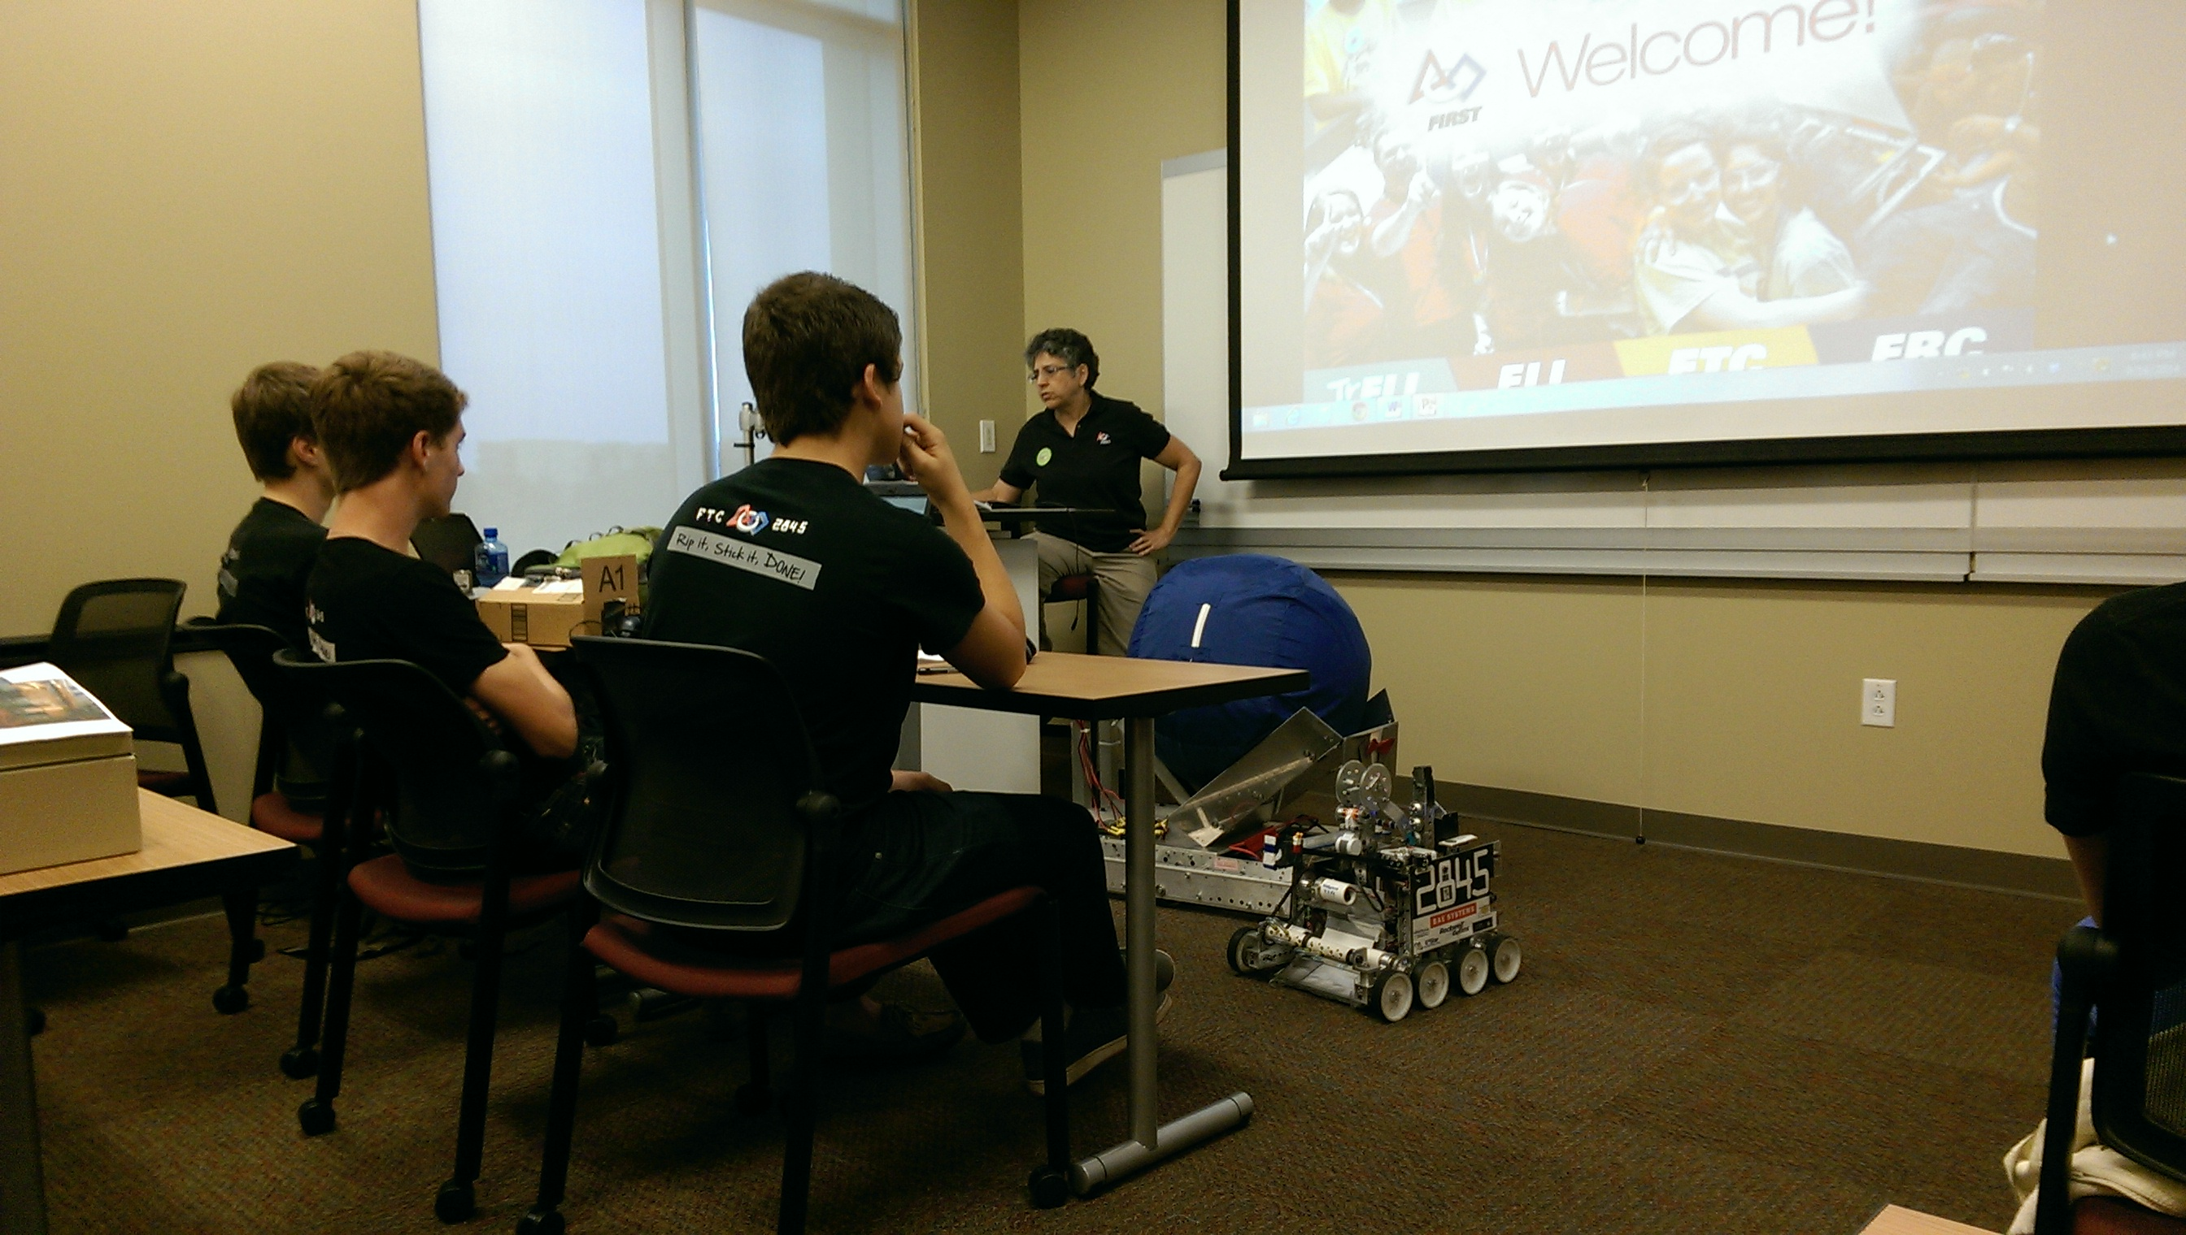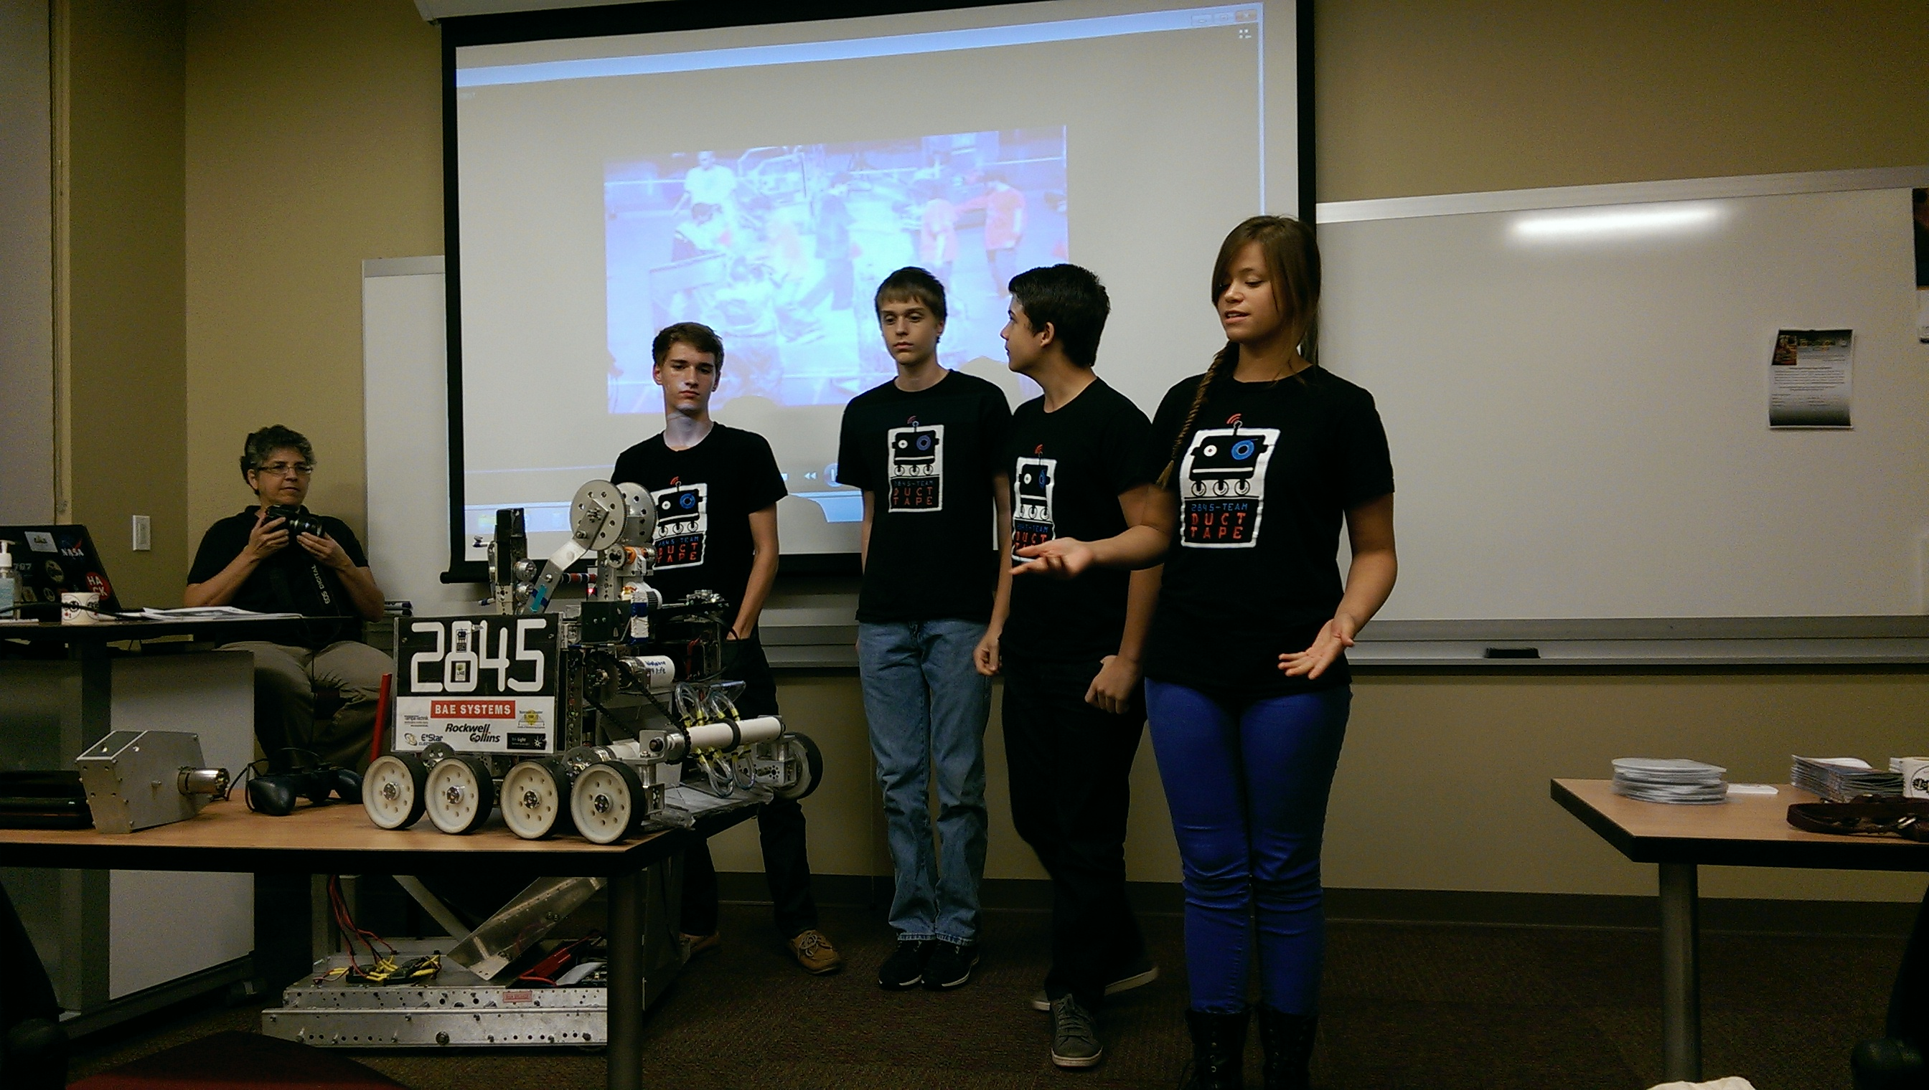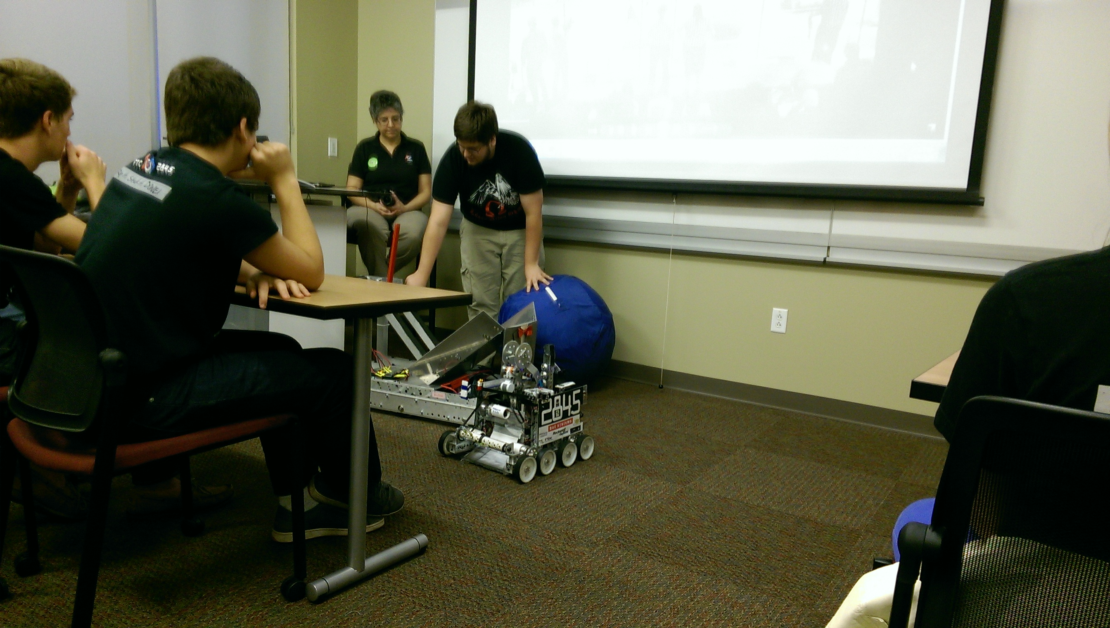

Thanks to Emma Alaba for the pictures!

