Life Member Meeting April 7, 2016
Life members were very busy on Thursday April 7 at the DeLand Municipal airport. Ten life members and three guests met with Pine Pienaar, Sales and Service Manager for Skydive DeLand (www.SkydiveDeLand.com) for an informative presentation about his firm. Skydive DeLand started some 32 years ago and is now one of the largest companies in the world in this field. Skydive DeLand has four airplanes: two of which have 22-23 seats and two with 16 seats. In the facility where we met, they have a gear store, both an indoor packing hangar and an outdoor packing area; training rooms and take-off and landing areas. Several blocks away they manufacture parachutes and other equipment.
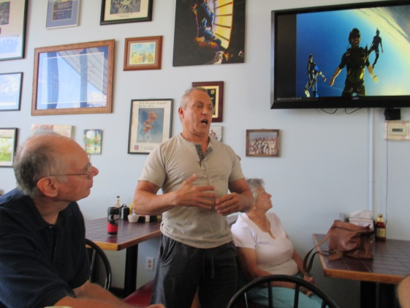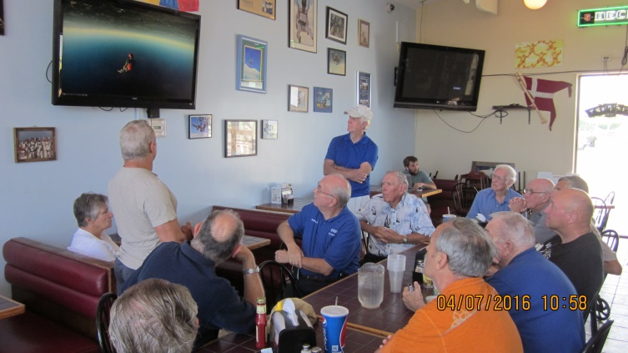
Pine Pienaar Group discussions on freefall video

It takes roughly 20 minutes for a plane to reach 13,500 feet. Coming down can take up to 8 minutes – 60-80 seconds in free-fall and 6-7 minutes with the parachute deployed. Normally the skydiver opens his parachute at about 5500 feet. Minimum altitude for opening the parachute is 2500 feet. Pine explained that the military still uses the umbrella parachute which can open as low as 800 feet, getting a soldier to the ground as quickly as possible.
Skydive DeLand has professional parachute packers available for their customers. Many customers prefer the professional and FAA certified packers as they can pack a chute in about five minutes (The average parachutist would need 30-40 minutes). There was a lively discussion between Pine and the audience over the many aspects of sky-diving, but we had to hold the discussion to an hour so we could move on to our next venue.
First, we had lunch in Skydive DeLand’s restaurant – The Perfect Spot. Most everyone agreed that the hamburgers were pretty good!
Our next stop, about ¼ mile down the road was the DeLand Naval Air Museum (http://www.delandnavalairmuseum.org/history.html).
In 1942, the Deland airport became The DeLand Naval Air Station, a training center for navy pilots flying carrier-based WWII fighters and dive bombers. Fifty years later, the Naval Air Museum came into existence, housed in the former Master of Arms residence, donated by the city of DeLand. Harold Bradeen was our tour host. After an introductory video, he explained some of the records, uniforms, and models on display in the main building. Al Helfrick gave us an overview of several of the military radio transmitters/receivers on display (all of which used vacuum tubes!!).
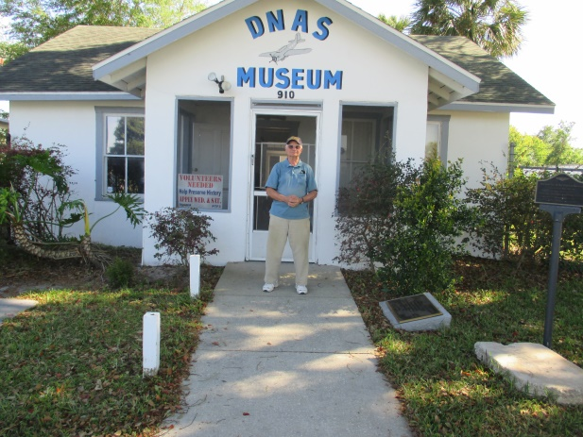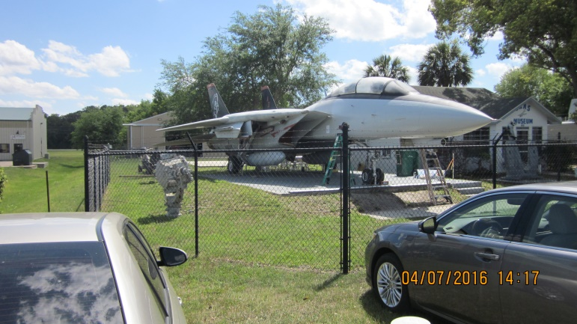
The museum sports an F14 fighter jet on one side of the main building and a PT boat on the other. Both artifacts are being carefully restored by volunteer groups. Going out the back door we saw the radial engine removed from the PBY aircraft donated to the museum and a WWII 40 mm portable gun capable of firing up to 200 rounds/minute.

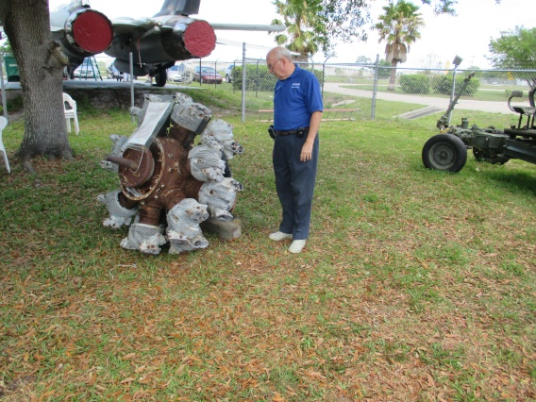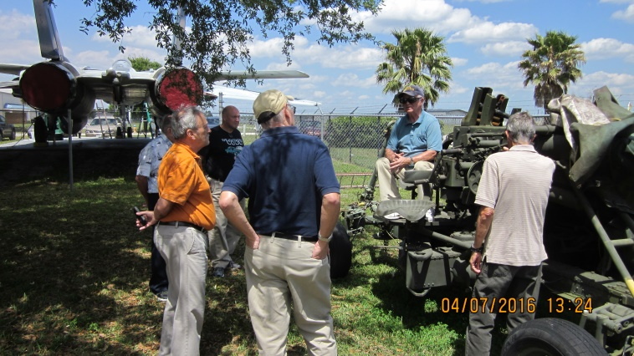

In a hangar building in back, a PBY that crashed into Lake Michigan during a training exercise. The cold waters preserved most of the plane for the 50 odd years it was under water. After the plane was placed in the museum, restoration workers discovered the remains of a signal flag in the engine exhaust duct, which must have caught fire and led to the plane’s pilot doing an emergency landing on the Lake. Embry Riddle students are aiding in the restoration of the PBY. Other displays were a Sikorsky EVAC helicopter of Vietnam war vintage, a WWII jeep and numerous other exhibits of 1940 to 1970 vintage.

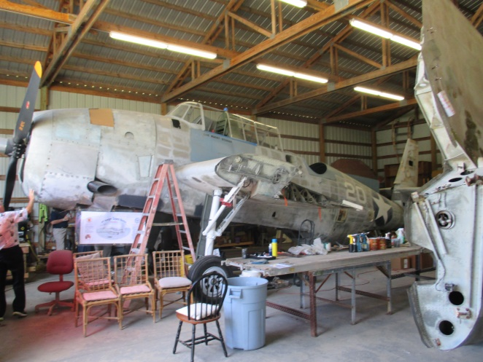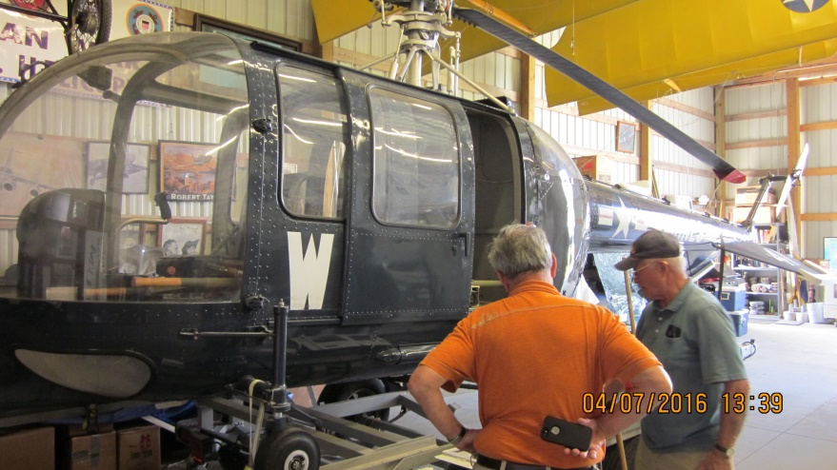

Patrol Torpedo boat PTF-3 was commissioned in 1962 and later stationed in DaNang, Vietnam. In 2001, it was donated to Boy Scout Troop 544, Orange City, and installed at the museum in 2005, where it is undergoing a complete refit.
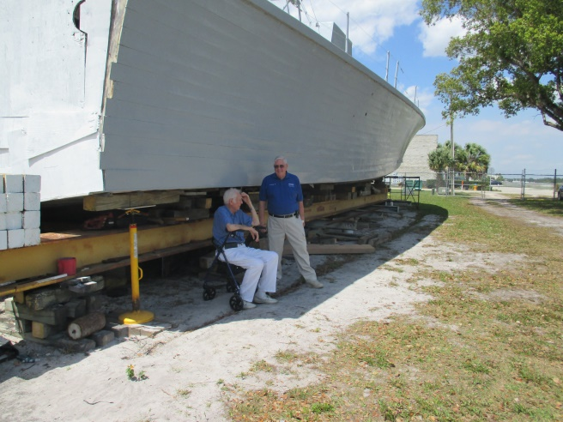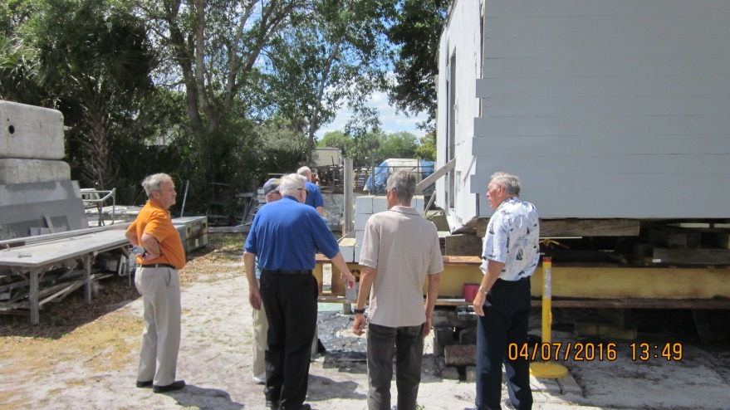
Our planned one hour stop at the museum stretched to over two hours, and could have been a lot more. The museum has wonderful documentation on all its artifacts, be they uniforms, airplanes, boats or whatever . I think most of us will re-visit the museum, as there is a lot more material than we could cover in the short time we had.
Submitted by Ron Gedney, Life Member Committee Chair

