Celebrating 50 years of IEEE ENCS: 1965 – 2015
Part 5: IEEE ENCS Student Branches in the 1980s
In Part 4 we learned about the formation of the IEEE student branch chapters in Eastern North Carolina. This installment will talk about events and changes in the 1980s.
Growth of Tech Sector in Eastern North Carolina
Membership in the IEEE Eastern North Carolina Section grew in the 1970s and 1980s as high technology companies moved to North Carolina. Burroughs Wellcome (now part of Glaxo Smith Kline) opened its RTP facility in 1970. The state of North Carolina established the Microelectronics Center of North Carolina (MCNC) in 1980. Many telecommunications companies were located in the RTP area, including Southern Bell, GTE, and Northern Telecom. Duke Power and Carolina Power and Light employed many electrical engineers in the Eastern North Carolina area. Growth in the tech sector in Eastern North Carolina created a demand for trained engineers, which resulted in higher enrollment in engineering programs. This in turn led to increase in membership in the IEEE Student Branch chapters.
IEEE Student Branch Officers in the 1980s
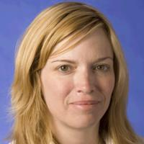
Figure 1. April Brown, Student Branch Chapter Secretary, NCSU, 1980-1; Professor of Electrical and Computer Engineering, Duke University.
After a period of “near dormancy” in the 1970s, IEEE Student Branch activity at NCSU began to increase in the early 1980s. This was due in part to the increased enrollment of women in engineering courses. This was reflected in the leadership of the IEEE Student Branch; in the 1980-81 academic year, the chair was Mary Jane Hunt, the vice chair was Janet Baldwin, and the Secretary was April Brown.
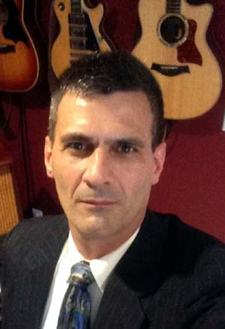
The following year, the Student Branch organized a “Student Professional Awareness Conference” to acquaint engineering students with the “practical side” of an engineering career, according to Student Branch chair Jim Ray. Held on October 14, 1982, the conference included presentations by representatives of Westinghouse, IBM, and South Central Bell Telephone Company. The Westinghouse speaker, Fred Twogood, encouraged students to develop good legal, information handling, and financial skills, in addition to their technical skills. Hans Cherney, the IBM representative, talked about the activities of IEEE at the national level. Eunice Rogers, the South Central Bell speaker, gave a talk on women and minorities in engineering.
Figure 2. Jim Ray, NCSU Student Branch Chair, 1981-2; ENCS Section Chair, 2010.

Tom Miller Becomes Counselor and Faculty Advisor – 1982
Dr. Thomas K. Miller, now Vice Provost at NCSU, became Counselor and Faculty Advisor to the IEEE Student Branch Chapter after joining the faculty in 1982. He had joined IEEE while a graduate student in the Biomedical Mathematics and Engineering (BMME) program at UNC. He recalls working with students to build an autonomous vehicle/robot called a "seeker" to enter in the SoutheastCon competition in March 1983. The seeker would locate the source of an audio source being driven at a specific frequency. As a UNC grad, Miller vividly remembers the rivalry between the Tarheels and the Wolfpack that year:
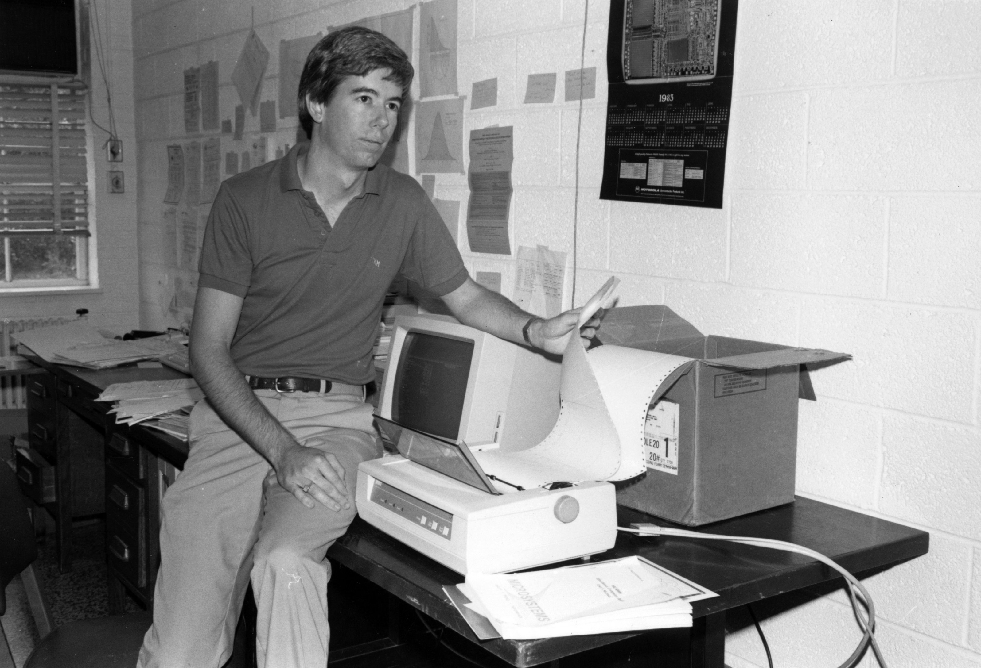
“I had just finished my PhD at Carolina in 1982 when the Tarheels won the national championship. I started at State that fall, and couldn't tell my students (except for a few) that I was a Carolina grad. The only clue was a small Carolina sticker on the back window of my Toyota Celica GT. The IEEE students and I were working days, nights, and weekends on the "seeker" project during March Madness, 1983, when the Cardiac Pack miraculously advanced through the NCAA tournament. I remember on the Saturday that the Pack beat Georgia to advance to the championship game against Houston, we hard-core engineers were working on the "seeker" in a lab in Daniels Hall while everyone else was watching the game. All of a sudden, screams erupted and crazed students were running wild all over campus. At that moment, I realized what had just happened, and it dawned on me that my Celica, with the Carolina sticker, was parked in front of Daniels. I fully expected to find it overturned! Fortunately, the sticker was small and inconspicuous enough that no one noticed!”
Figure 3. Tom Miller, IEEE Student Branch Chapter Counselor, 1980s. Courtesy Hill Library Archives
Tom Miller feels that IEEE membership has had a major influence on his professional career. “IEEE has been a great source of professional education and publishing for me over the years. I've published in a number of IEEE Transactions journals over the years, starting with IEEE Transactions on Biomedical Engineering in 1983. I've had a couple of invited papers in IEEE Computer, and one in the Proceedings of the IEEE.”

He received the best teacher award from the Eastern North Carolina Section, and won the Joseph M. Biedenbach Outstanding Engineering Educator Award (Region 3) in 1996. “These awards,” he says, “have been very meaningful to me.”

One of his most memorable contributions was being recruited by Ted Hissey to lead an IEEE expedition to the former Soviet Union to give seminars about entrepreneurship to engineers and students: “We went twice, in 1995 and 1997. Very interesting, trying to get across the notion of starting and building technology companies. We realized during our conversations with seminar attendees that most equated entrepreneurs with thieves - the Russian mafia!”
Do you have an IEEE Story to Share?
We would like to hear from ENCS members who have stories to share about their experiences as IEEE members. We’d like to know when, where, and why you joined, how IEEE membership has benefitted you, and any other stories you would like to share. If you have a story to share, please contact Tom Jepsen at tjepsen@ieee.org.
Want to learn more?
To learn more about the AIEE, IRE, and the North Carolina Section, go to http://sites.ieee.org/charlotte/files/2013/02/cltSecHistory29to79c.pdf
Answers to Last Month’s History Question
Which famous computer scientist was born in Durham, North Carolina, and was responsible for defining the “byte” as consisting of eight bits?
Frederick {“Fred”) Brooks, the developer of the IBM 360 mainframe computer systems architecture and noted engineering author, was born in Durham, North Carolina, on April 19, 1931. He earned a BS degree in Physics from Duke University in 1953, and a PhD in Applied Mathematics (Computer Science) from Harvard in 1956. He joined IBM in 1956, and began working on systems architecture for the emerging mainframe computer business, in the course of which he basically invented the field of computer architecture. When asked what his greatest technological achievement was, Brooks replied that “The most important single decision I ever made was to change the IBM 360 series from a 6-bit byte to an 8-bit byte, thereby enabling the use of lowercase letters. That change propagated everywhere.”
In 1964, Brooks joined the faculty of the University of North Carolina and created its Computer Science department. He continues to pursue active research in the fields of virtual reality and scientific visualization. He is the author of many books and papers, including The Mythical Man-Month, No Silver Bullet, and the Design of Design. He was named an IEEE Fellow in 1968, and a member of the National Academy of Science in 2001. His many awards include the A.W. Turing Award (1999) and the Eckert-Maucjhly Award (2004).
This Month’s History Question
Which RTP area university has the distinction of being the only university in the U.S. to host two National Science Foundation Engineering Research Centers? (Answers will appear in next month’s ENCS Newsletter)
Tom Jepsen 8/21/2015

Campus Organization Information Forms, Archives, D.H. Hill Library
“Conference Set to Aid State Engineers,” Technician, October 25, 1982.
Interview, Thomas K. Miller, August 18, 2015.
“Fred brooks,” Wikipedia, https://en.wikipedia.org/wiki/Fred_Brooks

