Celebrating 50 years of IEEE ENCS: 1965 – 2015
Part 6: The Eastern North Carolina Section 1990s-Today
The IEEE Eastern North Carolina Section experienced rapid growth in the 1990s and early 2000s, due to the “tech boom” of the 1990s and the development of the Internet. It became the largest section in North Carolina, with over 3000 members in an area stretching from Greensboro to the coast.
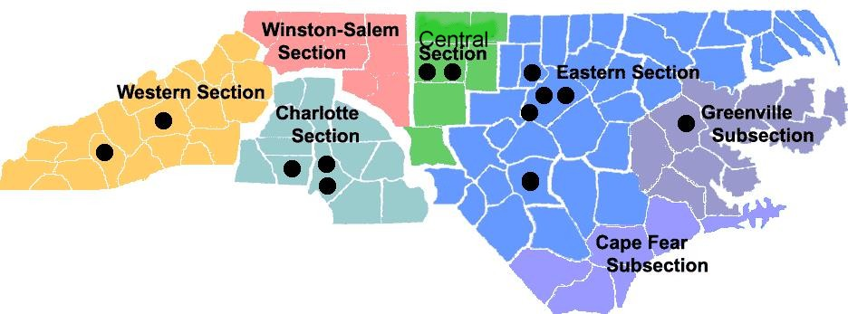
Eastern North Carolina Section Leaders 1990s--2015
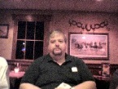
Charles Lord was ENCS Section Chair in 1993 and 1999. He has been active in many other IEEE activities at the section, NC Council, and regional levels. He now lives in Asheville, North Carolina.
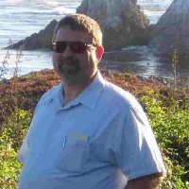
Chris Siegl was Section Chair in 2000 and 2001. He had also been Computer Society Chapter Chair, and during his term, many section meetings were held at the Sony Ericsson building in RTP. Chris also organized a tour of the Computer Science lab at UNC in Chapel Hill. His interest in railroading led to summer picnics at the New Hope Valley Railway in New Hill, North Carolina.
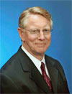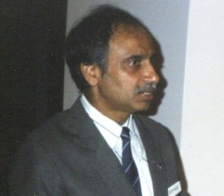
John Gibson became Section Chair in 2002. In 2003 he departed the RTP area for Orange County, California, passing the chairmanship to Abhinav Aggarwal, who was Section Chair for part of 2003. ENCS began to hold section meetings at the Instrumentation Society of America (ISA) building in RTP, and also at the Microelectronics Center of North Carolina (MCNC).
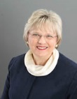
Mary Ellen Randall was Section Chair in 2004. She is also the founder of the ENCS Women in Engineering Affinity Group, and has held numerous positions at the NC Council and Region level. She is currently Region 3 Director.
Dave Ruden was Section Chair in 2005. During his term the student travel grant program for graduate students was established.
Roger Lawrence was Section Chair in 2006 and 2007. He also served as Chair of the joint PES/IAS Chapter for many years. During his tenure, summer picnics were held at the classical music station WCPE and the Museum of Life and Science in Durham. ENCS members also visited the Morehead Planetarium in Chapel Hill. The December 2007 section meeting on solar energy drew a “standing room only” crowd as presenters discussed various solar initiatives in North Carolina.
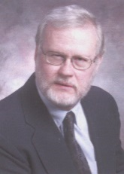
Tom Jepsen was Section Chair in 2008. He is Past Chair of both the Communications Society (COMSOC) and the Engineering in Medicine and Biology Society (EMBS). At this time many section meetings were held at North Carolina State University (NCSU). During his term, ENCS members attended a tour of the Renaissance Computing Institute (RENCI) at NCSU and a summer picnic at the New Hope Valley Railway.
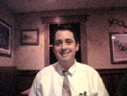
Dev Palmer became Section Chair in 2009. He was responsible for organizing the ACME (AP/CPMT/MTT/ED) joint chapter in 2003. He organized a summer picnic event at the Durham Bulls ballpark in Durham. He later served as Chair of the IEEE Region 3 Awards and Recognition Committee.

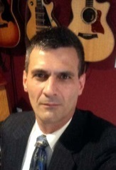
Jim Ray was Section Chair in 2010. He is also the founder and president of Neuse Networks. During his term, several section meetings were held at the First Flight Venture Center in RTP. The joint Intellectual Exchange Group (IEG) with the North Carolina Biotechnology Center was formed at this time.
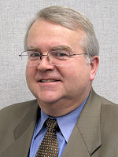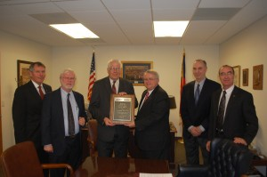
Paul Goodson was Section Chair in 2011. A summer event was held at the North Carolina Museum of Natural History during his term. Paul also was responsible for presenting Congressman David with the IEEE-USA Distinguished Public Service Award in September 2013 for his long term support for engineering, science, and technology research and education.
Tom Jepsen was Section Chair again in 2012. During his term, the ENCS Executive Committee (EXCOM) began holding online virtual meetings. A summer event was held at the Carolina Mudcats ballpark.
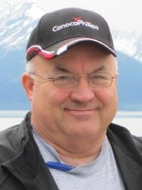
Ken Pigg was Section chair in 2013 and 2014. He had previously held many Region 5 offices, including serving as Oklahoma City Section Chair in 2003. During his term as ENCS Section Chair, the ENCS PES/IAS Chapter won the PES High Performing Chapter Program Award and the IAS Outstanding Large Joint Chapter Award.
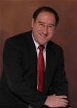
Grayson Randall is Section Chair for 2015. He had previously been Chapter Chair of the Robotics and Automation Society chapter, and participated in both the Insight Racing and DARPA Grand Challenge autonomous vehicle initiatives as a mentor. This years’ summer event was a picnic at Jordan Lake.
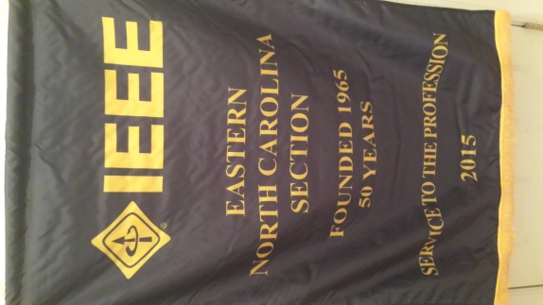
In November, the Eastern North Carolina Section will celebrate its 50th anniversary with a banquet at the Prestonwood Country Club in Cary.
Answers to Last Month’s History Question
Which RTP area university has the distinction of being the only university in the U.S. to host two National Science Foundation Engineering Research Centers?
North Carolina State University is the only university in the U.S. to host two NSF Engineering Research Centers – FREEDM and ASSIST. The Future Renewable Electric Energy Delivery and Management (FREEDM) Systems Center was established in 2008 to conduct research to transform the nation's power grid into an efficient network that integrates alternative energy generation and novel storage methods with existing power sources. The Center's overall goal is to facilitate the use of green energy sources, reduce the environmental impact of carbon emissions, and alleviate the growing energy crisis.
The NSF Engineering Research Center (ERC) for FREEDM Systems is based at North Carolina State University (NCSU), in partnership with Arizona State University, Florida A&M University, Florida State University, and Missouri University of Science and Technology. Rheinisch-Westfälische Technische Hochschule (RWTH) Aachen University in Germany and the Swiss Federal Institute of Technology contribute additional expertise and international perspectives.
The National Science Foundation (NSF) Nanosystems Engineering Research Center for Advanced Self-Powered Systems of Integrated Sensors and Technologies (ASSIST) was established at NCSU in 2012 to create self-powered devices to help people monitor their health and understand how the surrounding environment affects it. The center is led by North Carolina State University and includes three partner institutions – Penn State University, the University of Virginia, and Florida International University. Also included in our efforts are UNC-Chapel Hill, the University of Michigan, and universities in Australia, Japan, and South Korea.
ASSIST researchers are using the tiniest of materials to develop self-powered health monitoring sensors and devices. These devices could be worn on the chest like a patch, on the wrist like a watch, as a cap that fits over a tooth, or in other ways, depending on the biological system that’s being monitored. The devices developed at the center could transform health care by improving the way doctors, patients, and researchers gather and interpret important health data.
Tcj 10/9

“NRC Launches an ERC for Clean Energy Grid.” NSF Website, http://www.nsf.gov/news/news_summ.jsp?cntn_id=112179
“Message from the Director,” ASSIST Website, http://assist.ncsu.edu/about/from-the-director/

